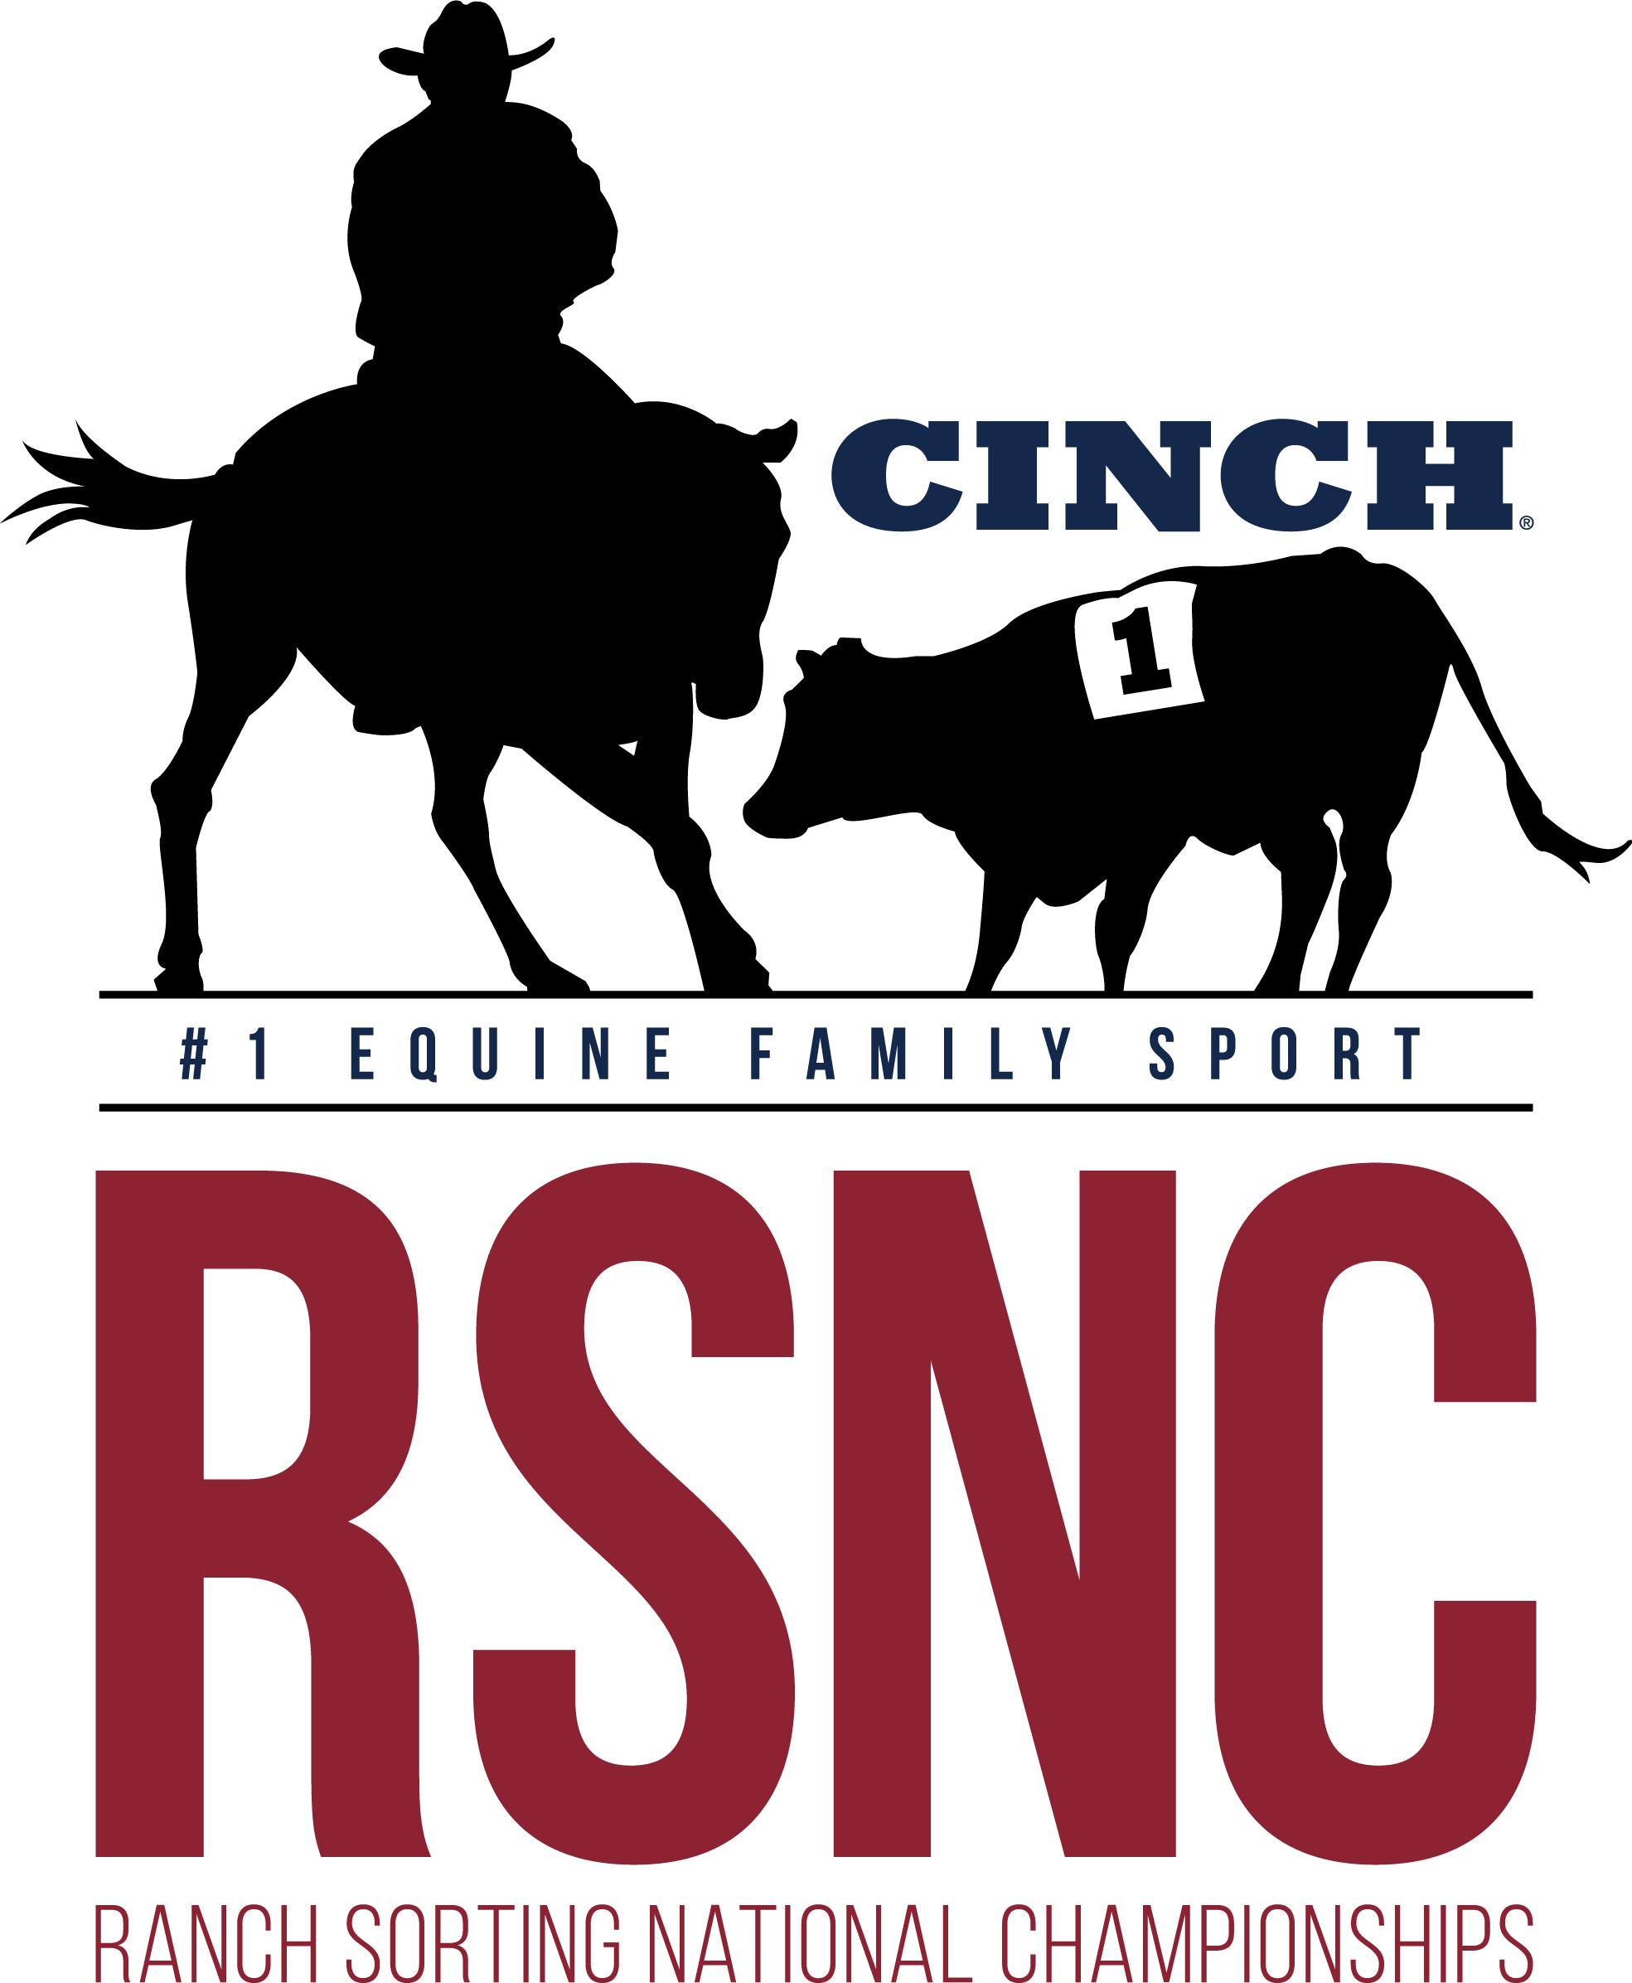

BSC ARENA
Waynesboro Ga.

Ranch Sorting
National Championships

1 DAY SHOW!!!
Covered
Arena
Saturday December 9th
All New Contestants
Receive a free RSNC Membership!

Concessions
Available

REVISED FLYER
No Friday Show
SPECIAL SANTIONED ALL DRAW CLASS

Saturday December 9th
*Books open @ 9am - Sort @ 10am*
Masters #10 HC - $29 EF
All Draw #10 HC W/#4 Incentive - (10 Ride Limit) - $29 EF - ($200 Added)
#11 Rookie HC (2 cap on sorter) - $29 EF
#10 Beginner Ranch Hand HC (1 cap sorter) - $27 EF
All Levels HC (# 2 Floor) - $47 EF – (60% Payback)

All Classes 50% payback Except All Levels 60%
*Entry Fees include a $3/entry RSNC sanctioning fee and $4/entry cattle fee
Mandatory Draw- Pick 1 Automatically Draw 1 (Pick up to 4 or Draw All 5)
All Draw Class (Draw 1 to 10 rides)

Location:  BSC Covered Arena  3976 Hwy 24 South  Waynesboro, Ga | Call to Reserve Stalls and RV  706-551-2190  **All info on flyer subject to change**
Contact Johnny Lovett at #706-551-2190 or Cliff Chancey at #706-840-3971 with any questions – Entry Fees Payable with Cash or Good check Only

